**DATE: 07-10-2022**

**WEBLEM 3:**

**Introduction to Conformational search studies using BALLOON software**

**(**[**http://users.abo.fi/mivainio/balloon/index.php**](http://users.abo.fi/mivainio/balloon/index.php)**)**

**AIM:**

Introduction to conformational search and Balloon software.

**INTRODUCTION TO CONFORMATIONAL SEARCH:**

3-D ligand conformations are required for most ligand-based drug-design methods, such as pharmacophore modeling, shape-based screening, and 3-D QSAR model building. Many studies of conformational search methods have focused on the reproduction of crystal structures; however, for ligand-based modeling, the key question is how to generate a ligand alignment that produces the best results for a given query molecule. In general, we find that virtual screening results are relatively insensitive to the conformational search protocol; hence, a conformational search method that generates fewer conformations could be considered ‘‘better’’ because it is more computationally efficient for screening.

A number of methods have been described to generate ligand conformations, such as:

1. Random torsional angle changes
2. Random coordinate changes
3. Distance geometry
4. Rule-based methods
5. Knowledge-based methods
6. Low mode search

Each mode has its strength and weaknesses and the performance depends on multiple factors. All the methods are “unbiased”, in that they do no explicitly consider information about the query molecule being used in the virtual screen or QSAR alignments. While generating more conformations will necessarily lead to an increased probability of finding a bioactive conformation, there are potential of finding a bioactive conformation, there are potential drawbacks to generating conformations.

**NEED OF CONFORMATIONAL SEARCH:**

* Conformational analysis is an important step in molecular modeling as it is necessary to reduce time spent in screening of compounds for activity.
* Most drugs are flexible molecules with the ability to adopt different conformations by means of rotation about single bonds.
* Conformations play an important role in prediction of not just physico-chemical properties but also the biological activity of the drug.
* The major objective of conformational analysis is to gain insight on conformational characteristics of drugs and also to identify the relation between the role of conformational flexibility and their activity.
* Therefore, it plays a significant role in computer aided design as well.
* The significance of conformational analysis not just extends to computational docking and screening but also for lead optimization.
* The analysis of the conformational collection that was sampled and optimized is essential so as to ascertain the conformational properties of the molecule that is being studied.
* This helps to underline the global properties and to exemplify features of overall flexibility and to recognize common inclination in the conformation set.
* Alternatively, it may be used to identify a smaller subset of characteristic low energy conformations, which may be used to direct future drug development efforts.

**INTRODUCTION TO BALLOON:**

Balloon creates 3D atomic coordinates from molecular connectivity via distance geometry and confomer ensembles using a multi-objective genetic algorithm. The input can be SMILES, SDF or MOL2 format. Output is SDF or MOL2. Flexibility of aliphatic rings and stereochemistry about double bonds and tetrahedral chiral atoms is handled.

The software has been ported to Linux, Mac OS X, and Microsoft Windows platforms.

Balloon was introduced to the scientific community during a poster session of the The 16th European Symposium on Quantitative Structure-Activity Relationships & Molecular Modelling 10 - 17 September 2006 held in MSC Opera on the Mediterranean Sea. There were a couple of other studies about conformational analysis presented as posters as well, which indicates that despite the problem has been studied for decades people still do not consider the job done.

**PROCEDURE (INSTALLATION OF BALLOON):**

1. Navigate to the official Balloon website (<http://users.abo.fi/mivainio/balloon/>)
2. Go to “Downloads” section
3. Scroll down to the bottom and selected your platform for which you want to download the software.
4. A zip file will be downloaded.
5. Create a folder or directly extract the contents of the zip file into this folder or at the desired location.
6. The installation is completed.

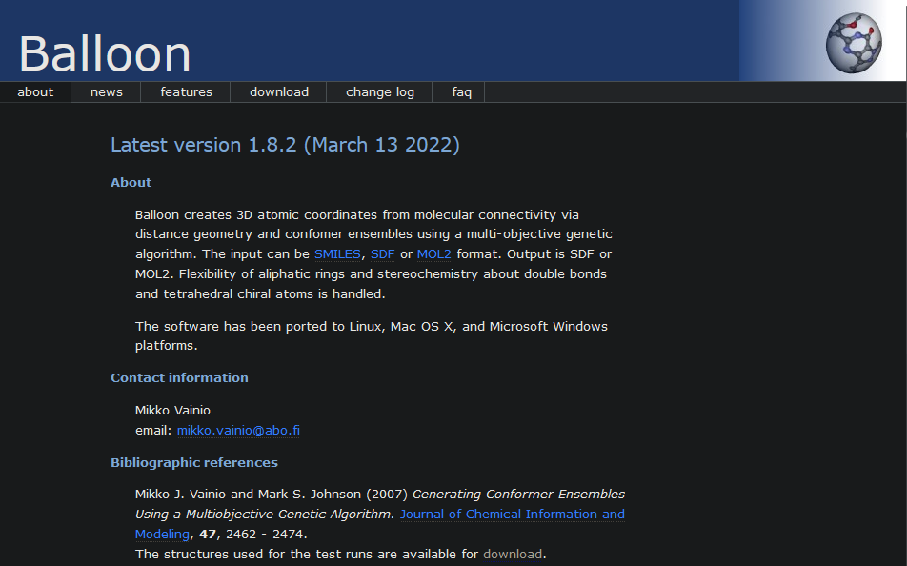

Figure 1: Homepage of Balloon Software

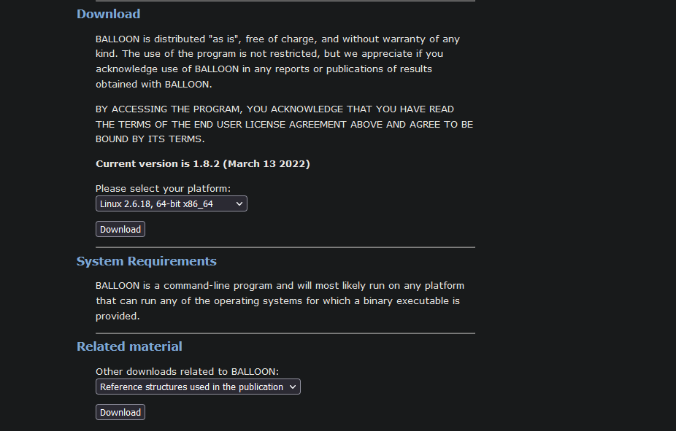

Figure 2: Bottom of Downloads page where the platform selection is there

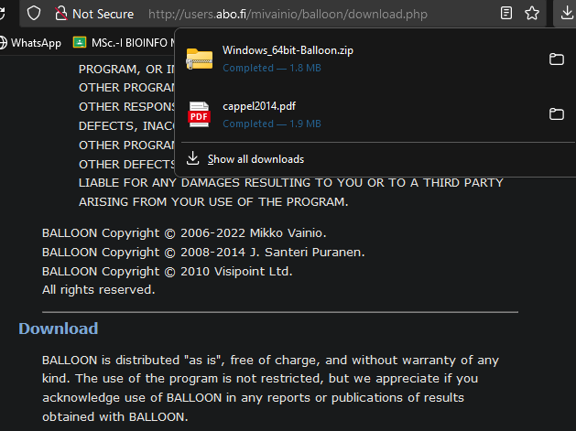

Figure 3: The downloaded ZIP file

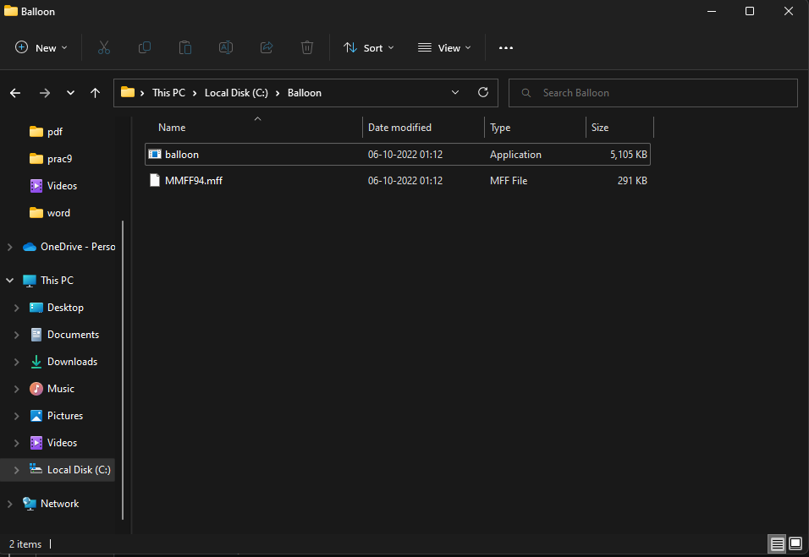

Figure 4: Folder with the contents of the ZIP file extracted

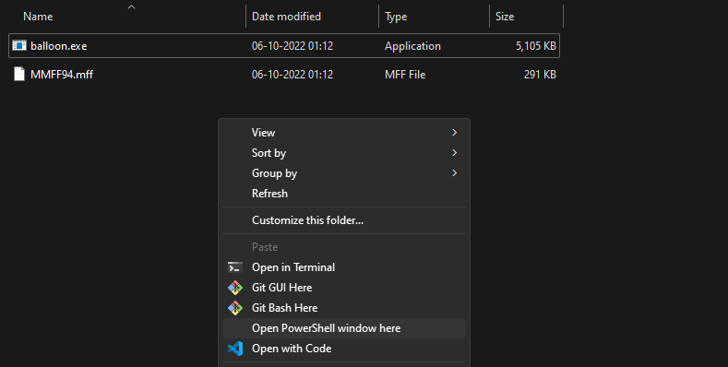

Figure 5: Open PowerSHell Option after Pressing Shift+Right click for BALLOON Software



Figure 6: Windows PowerShell for BALLOON Software

**REFERENCES:**

1. Cappel, D., Dixon, S. L., Sherman, W., & Duan, J. (2014, November 19). Exploring conformational search protocols for ligand-based virtual screening and 3-D QSAR modeling. Journal of Computer-Aided Molecular Design, 29(2), 165–182. <https://doi.org/10.1007/s10822-014-9813-4>
2. 8.2: Conformational Analysis. (2020, May 12). Chemistry LibreTexts. <https://chem.libretexts.org/Bookshelves/Organic_Chemistry/Organic_Chemistry_I_(Cortes)/08%3A_Conformational_Analysis>

__________________________________________________________

**DATE: 07-10-2022**

**Weblem 3a:**

**Introduction to Conformational search studies using BALLOON Software**

**(http://users.abo.fi/mivainio/balloon/index.php)**

**AIM:**

To generate and analyze various structural conformation for Penicillin (Pubchem ID-5904) molecule using Balloon software.

**INTRODUCTION:**

Balloon creates 3D atomic coordinates from molecular connectivity via distance geometry and confomer ensembles using a multi-objective genetic algorithm. The input can be SMILES, SDF or MOL2 format. Output is SDF or MOL2. Flexibility of aliphatic rings and stereochemistry about double bonds and tetrahedral chiral atoms is handled.

Penicillin G is a broad-spectrum, beta-lactam naturally occurring penicillin antibiotic with antibacterial activity. Penicillin G binds to and inactivates the penicillin binding proteins (PBPs) located inside the bacterial cell wall. Inactivation of PBPs interferes with the cross-linkage of peptidoglycan chains necessary for bacterial cell wall strength and rigidity. This interrupts bacterial cell wall synthesis and results in the weakening of the bacterial cell wall and eventually causing cell lysis.

**METHODOLOGY:**

1. Download the sdf file of the query Penicillin G from PubChem Database. <https://pubchem.ncbi.nlm.nih.gov/>
2. Paste the structure in the folder where BALLOON Software installed.
3. Open BALLOON Software in PowerShell by pressing Shift+Right key.
4. Type the command “.\balloon.exe -f .\MMFF94.mff --nconfs 20 --nGenerations 5 --input- file .\Structure2D_CID_6167.sdf --output-file .\Structure2D_CID_6167_OPT.sdf”
5. Press the “Enter” button.
6. Command will run within a few seconds.
7. Observe the results and from output file extract the energy data for each conformations.

**NOTE: DESCRIPTION OF COMMAND:**

* 1. ./balloon.exe (specifies which exe to execute in our case it’s Balloon)
  2. -f MMFF94.mff (symbolizes and specifies which forcefield file should be used)
  3. --nconfs 20 (specifies the number of conformations)
  4. --nGenerations 5 (specifies the number of generations)
  5. –input-file Structure2D_CID_5904.sdf (specifies the input file)
  6. –output-file Structure2D_CID_5904_out.sdf (specifies the output file)

**OBSERVATIONS:**

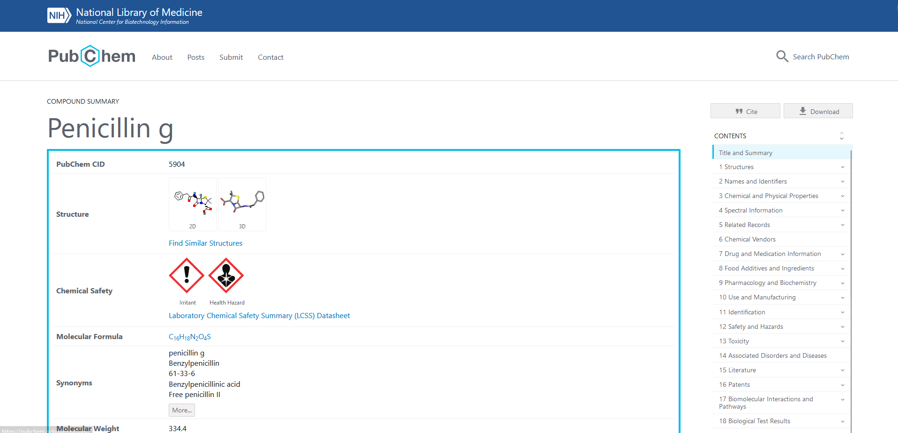

**Figure 1: PubChem page for my query Penicillin**

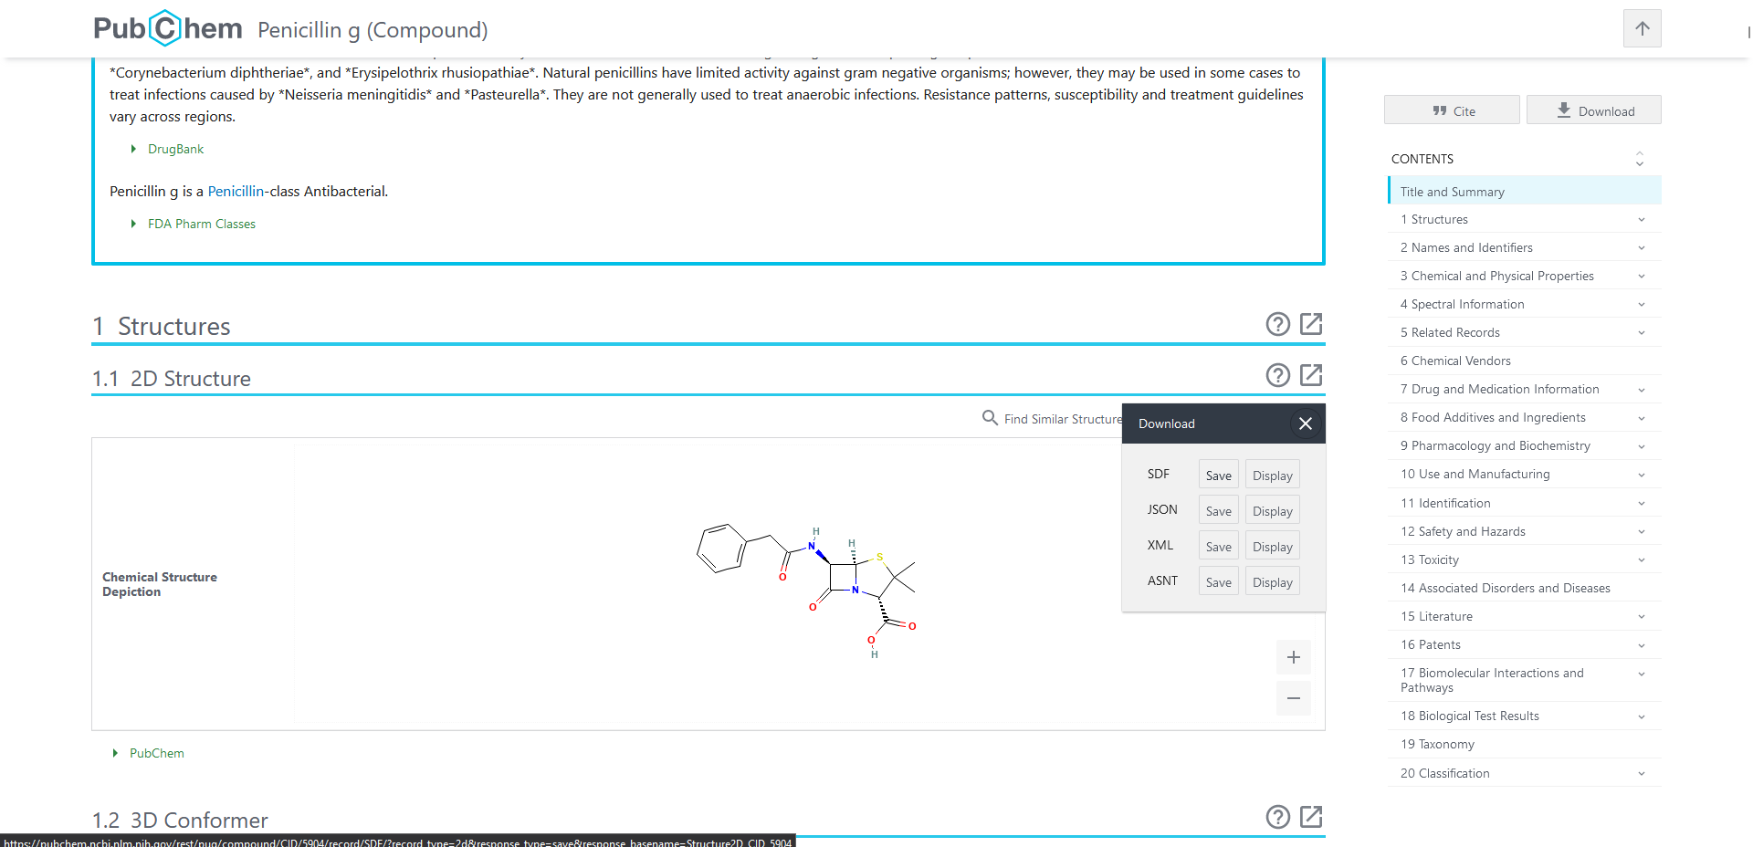

**Figure 2: Download the 2-D structure of the query in .sdf format**

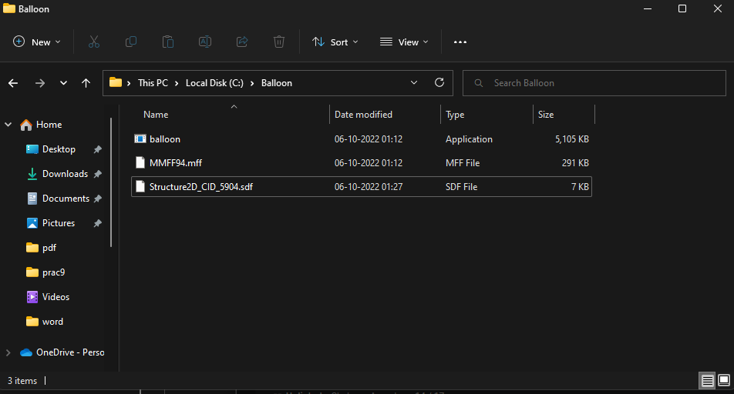

**Figure 3: Place the downloaded structure in the same folder as the Balloon Installation**



**Figure 4: Right-click in the blank area of the folder and click “Open PowerShell window here”**

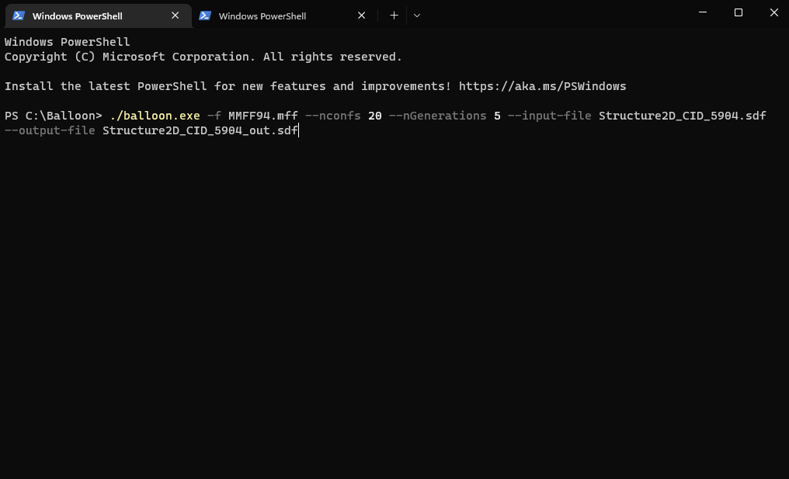

**Figure 5: Enter Command to Generate Conformations for Penicillin Structure**

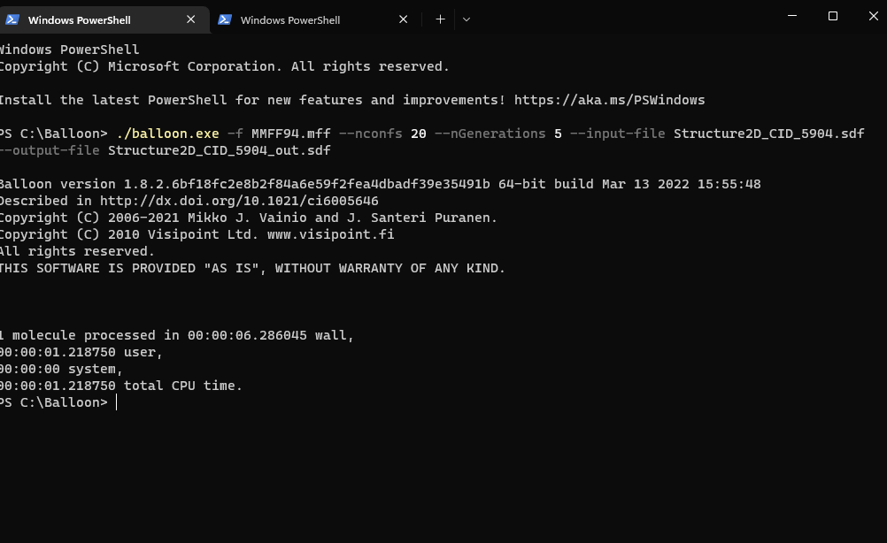

**Figure 7: Execution of command for conformation generations**

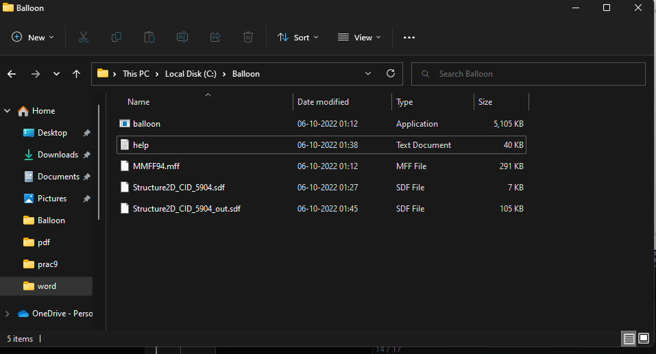

**Figure 8: An output file has now been generated in folder**

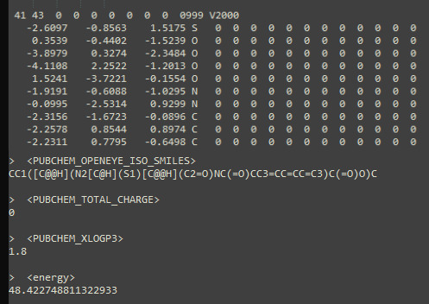

**Figure 9: Output File Opening in Notepad Containing Information of Conformations**

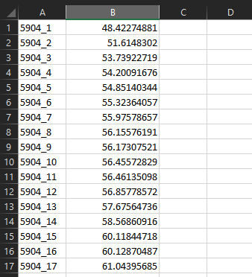

**Figure 10: Excel Sheet showing Generated Conformations with lowest Energies by BALLOON Software**

**RESULTS:**To generate and analyze various structural conformations for Penicillin molecule , BALLOON software was used. It had provided 17 different conformations for query structure with their lowest energies. Also, other information like monoisotopic weight, smiles, LogP values etc. were interpreted by BALLOON Software.

**CONCLUSION:**

Balloon creates 3D atomic coordinates from molecular connectivity via distance geometry and conformer ensembles using a multi-objective genetic algorithm. It is distributed "as is", free of charge, and without warranty of any kind. Its a command-line program and will most likely run on any platform that can run any of the operating systems for which a binary executable is provided. The performance of Balloon is dependent on the performance of the used force field, both time-wise and with regard to the quality of produced geometries.

**REFERENCES:**

1. Huhtala, M. V. A. M. (n.d.). Balloon. Retrieved October 6, 2022, from http://users.abo.fi/mivainio/balloon/index.php
2. NCBI - WWW Error Blocked Diagnostic. (n.d.). Retrieved October 6, 2022, from <https://pubchem.ncbi.nlm.nih.gov/compound/5904>

______________________________________________________________